**Conditional Probability and Bayes Theorem**

#### **1. Conditional Probability**

Conditional probability measures the likelihood of an event occurring **given that another event has already occurred**.

✅ **Formula:**

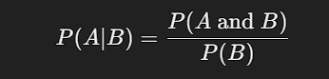

where:

* P(A∣B) = Probability of **A occurring given that B has already occurred**
* P(A and B) = Probability of **both A and B occurring**
* P(B) = Probability of **B occurring**

📌 **Example 1: Selecting a Card**

* **A = Drawing a King**
* **B = The first card drawn is an Ace (without replacement)**
* **Total Cards:** 52
* **P(Ace first) =** 4\52
* **P(King after an Ace) =** 4\51

So,

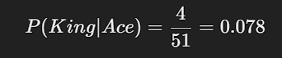

#### **2. Bayes' Theorem**

Bayes' Theorem is used to **update probabilities** based on new information.

✅ **Formula:**

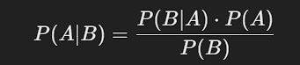

where:

* P(A∣B) = Probability of **A given B**
* P(B∣A) = Probability of **B given A**
* P(A) = Prior probability of **A**
* P(B) = Total probability of **B**

📌 **Example 2: Medical Testing** Suppose:

* A disease affects **1%** of a population (P(Disease)=0.01).
* A test is **95% accurate** for detecting the disease (P(Positive∣Disease)=0.95).
* The test has a **5% false positive rate** (P(Positive∣NoDisease)=0.05).

Using Bayes’ Theorem,

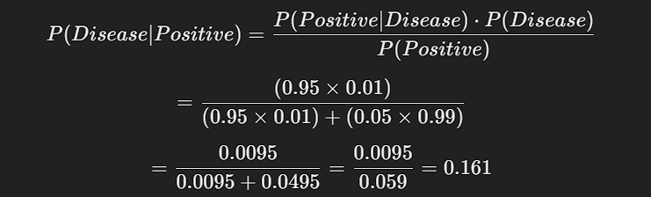

So, even if a person **tests positive**, the actual probability of them having the disease is **only 16.1%**, due to the false positive rate!

### **Python Example (Bayes' Theorem)**

# Given probabilities

P_disease = 0.01 # Prior probability of disease

P_positive_given_disease = 0.95 # Sensitivity

P_positive_given_no_disease = 0.05 # False positive rate

P_no_disease = 1 - P_disease # Probability of no disease

# Total probability of a positive test

P_positive = (P_positive_given_disease * P_disease) + (P_positive_given_no_disease * P_no_disease)

# Bayes' Theorem calculation

P_disease_given_positive = (P_positive_given_disease * P_disease) / P_positive

print("Probability of having the disease given a positive test:", round(P_disease_given_positi